Working with ISCSI in Linux

To manage block IO over IP.(ISCSI proto over Ethernet). ISCSI uses TCP/IP port 3260 by default for storage access.

Linux-lun1 is the LUN which I have provisioned from open filer. (That’s it from the storage side)

Linux-lun1 is mapped to iqn.2006-01.com.openfiler:tsn.486ad7ff53e8

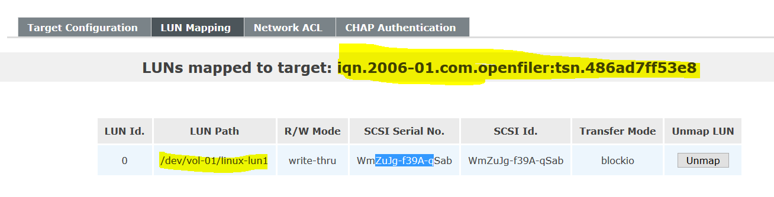

Server Side

Existing disk in my centos box ( that’s the OS disk in my box)

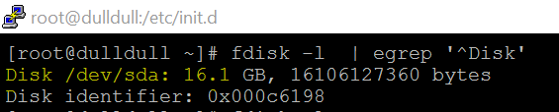

These SCSI controller available in my centos box (so will have to scan host0,host1 & host2 )

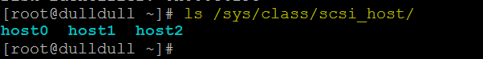

To access iscsi storage will have to install the iscsi initiator package on centos server side

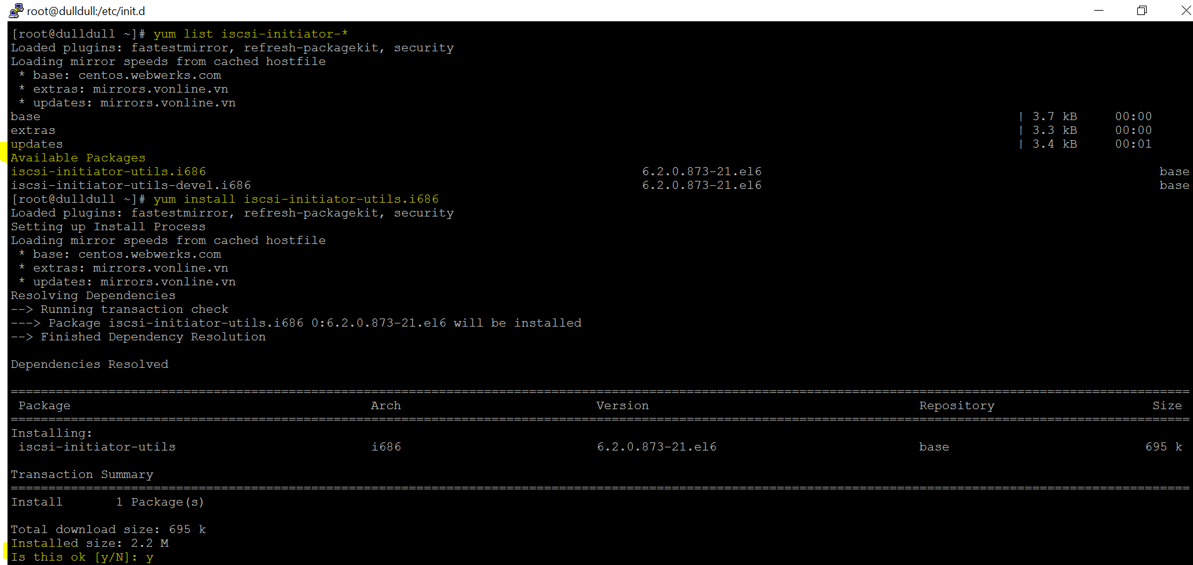

Make sure you start the ISCSI service across reboot (chkconfig iscsi on).

Now lets try to discover the ISCSI storage target details ( Lun which we created on openfiler)

0.51 & 0.50 is the IP of openfiler

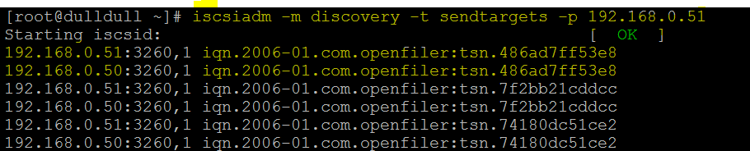

Login to ISCSI target to access the LUN (login to both IP of openfiler )

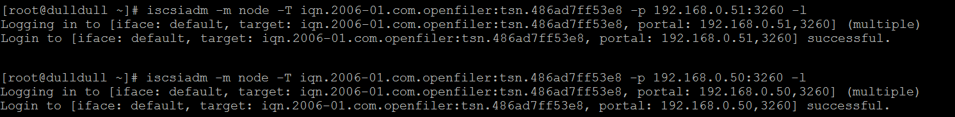

Scan the SCSI disks using below command & verify new disk with fdisk (same Linux-lun1 is visible as /dev/sdb /dev/sdc …(it is showing two paths because we added both openfiler ip )

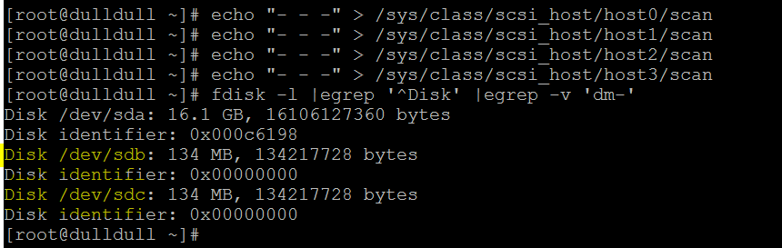

Let’s install device mapper (In Linux it is device mapper who manages multipathing)

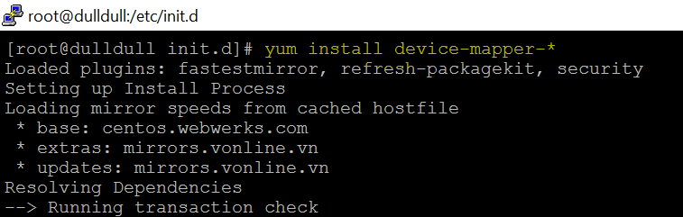

If you do query list on device mapper package you will see that there is no conf file…& you will have to copy the sample file from share to /etc…refer below screen

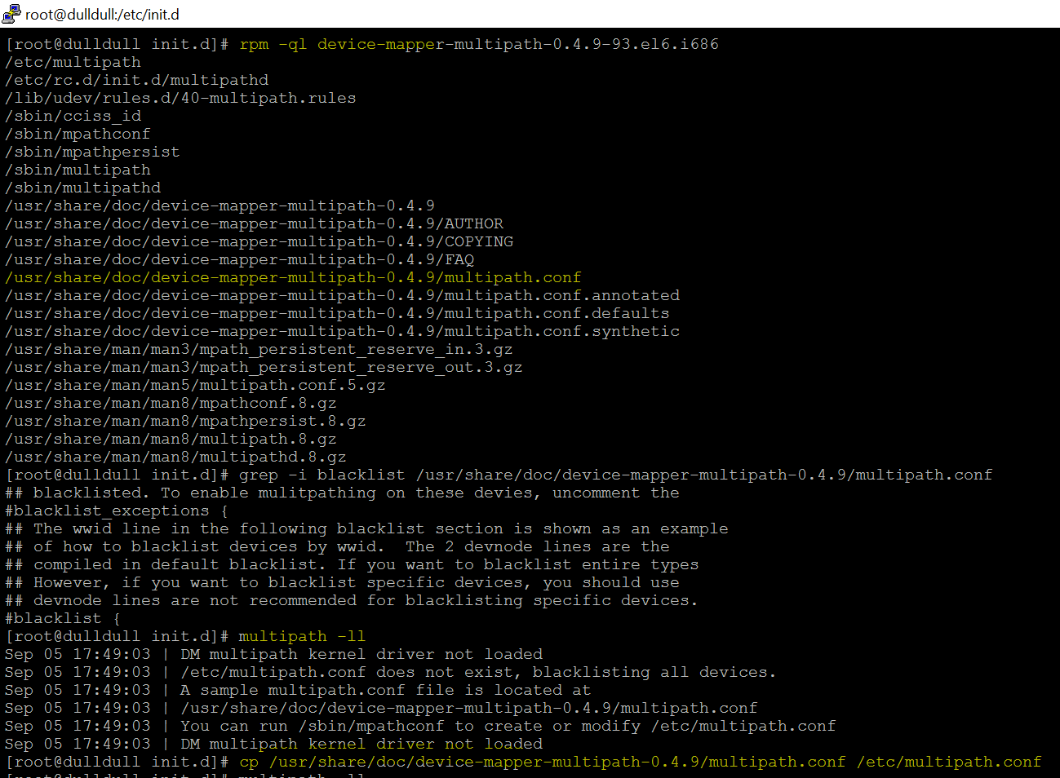

After copying the conf file start the service & run multipath –ll to list multipath details

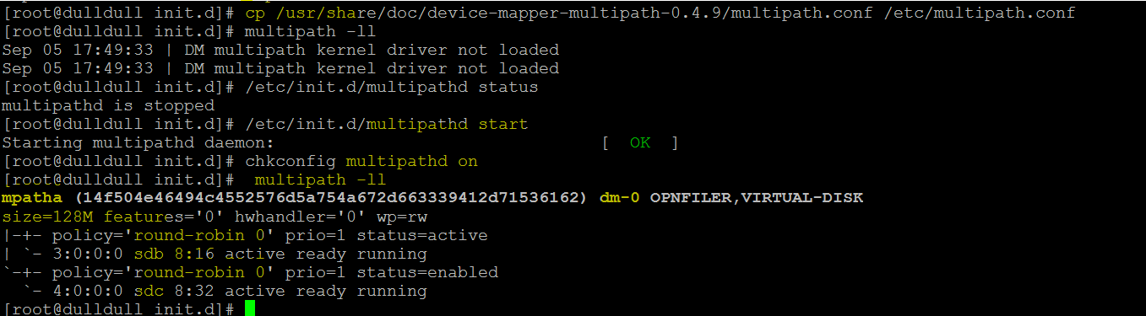

Fdisk will list the new driver /dev/mapper/mpatha

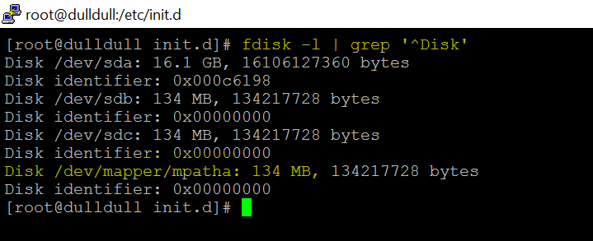

Create partition on iscsi storage LUN

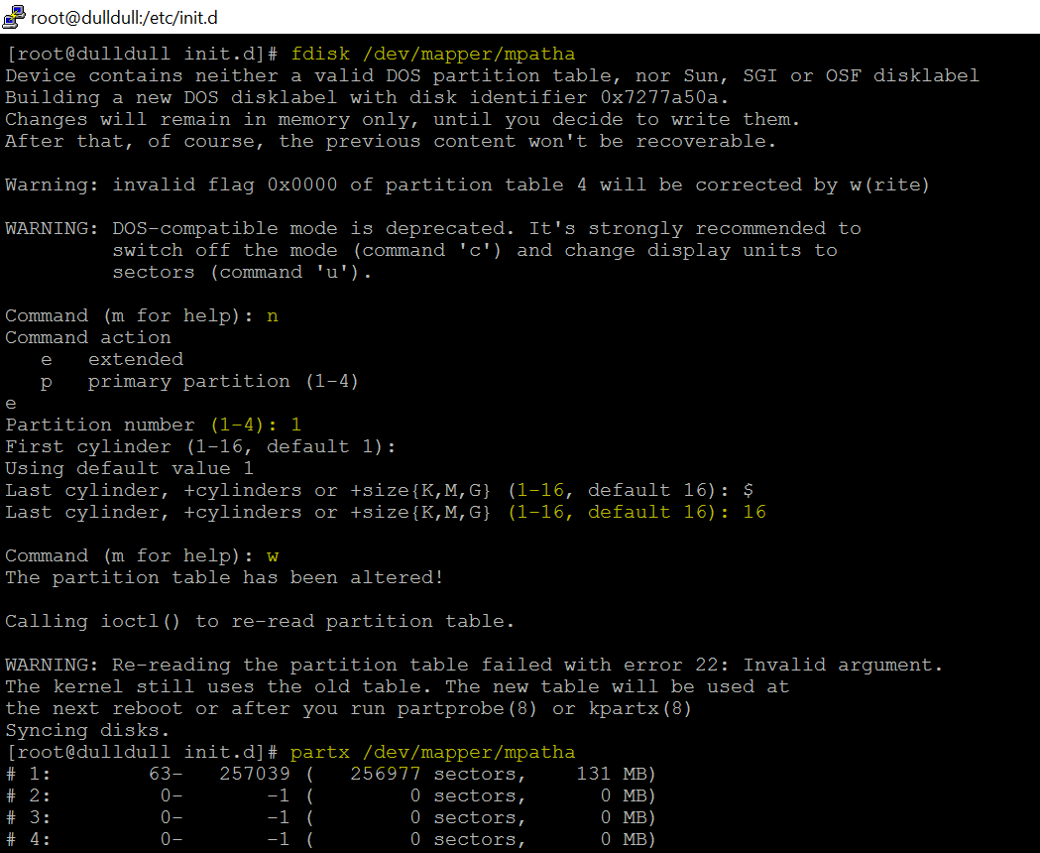

Now create FS , mount it & access the same. (entry in fstab)

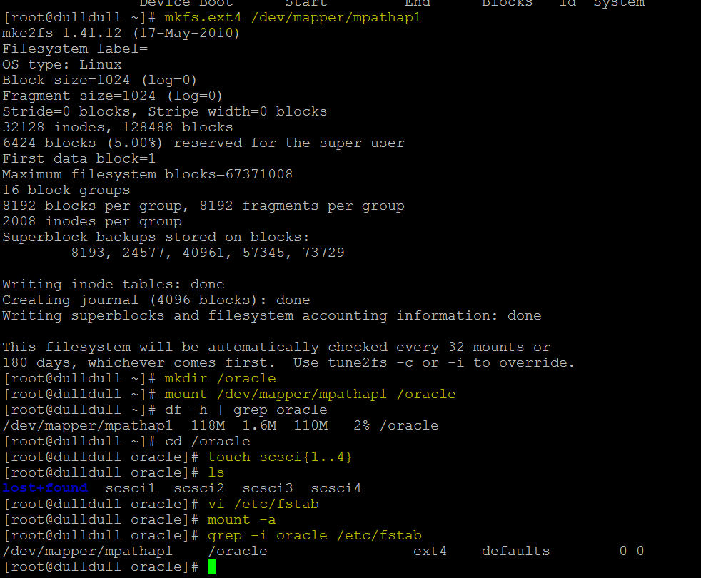

If you want to logout from the iscsi session, then use the below command.

iscsiadm -m node -T iqn.2006-01.com.openfiler:tsn.c27c73a506b2 -p 192.168.10.10:3260 -u

To remove the target completely from this host,use the below command after logout from the session.You need to restart the iscsi service to see the changes.

iscsiadm -m node -T iqn.2006-01.com.openfiler:tsn.c27c73a506b2 -p 192.168.10.10:3260 -o delete

service iscsi restart